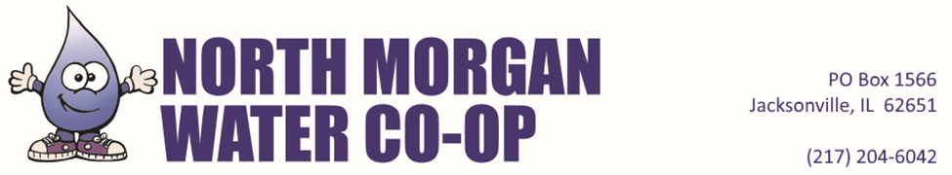

**RENTER EXEMPT CONTRACT**

Owners of Membership #________________guarantee prompt payment of all water charges by North Morgan Water Cooperative incurred by:

______________________________________________

(Renter Name)

______________________________________________

(Address)

______________________________________________

(City, State, Zip Code)

______________________________________________

(Telephone Number)

______________________________________________

(Email)

And thus, the $100 rent deposit shall be waived.

I (we) agree to become a customer of the system as soon as service is available to the above property and to pay the charges required by the rules, rates and regulations of the governing board including the monthly minimum once the water becomes available (______) ((Please Initial).

Print____________________________________Signed________________________________

(Owner) (Owner)

Date____________________________________

Print_____________________________________Signed_______________________________

(Renter) (Renter)

Date_____________________________________

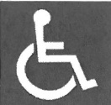North Morgan Water Coop. is an equal opportunity provider and employer. If you wish to file a Civil Rights program complaint of discrimination, complete the USDA Program Discrimination Complaint Form, found online at <http://www.ascr.usda.gov/complaint_filing_cust.html>, or at any USDA office, or call (866) 632-9992 to request the form. You may also write a letter containing all of the information requested in the form. Send your completed complaint form or letter to us by mail at U.S. Department of Agriculture, Director, Office of Adjudication, 1400 Independence Avenue, S.W., Washington, D.C. 20250-9410, by fax (202) 690-7442 or email at [program.intake@usda.gov](mailto:program.intake@usda.gov).